**COGNIZANT JAVA FSE WEEK 1 OUTPUT**

**1.SINGLETONPATTERN OUTPUT**

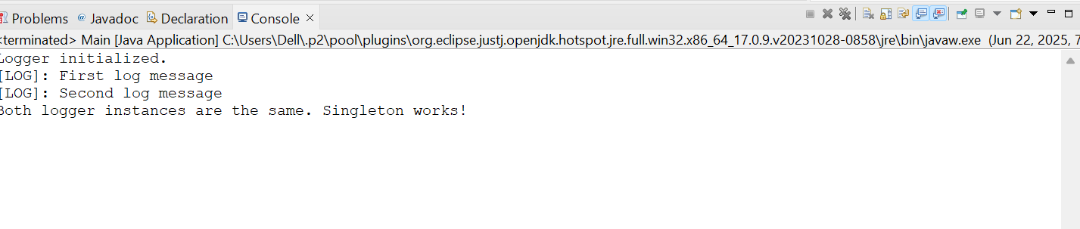

**2.FACTORYMETHOD OUTPUT**

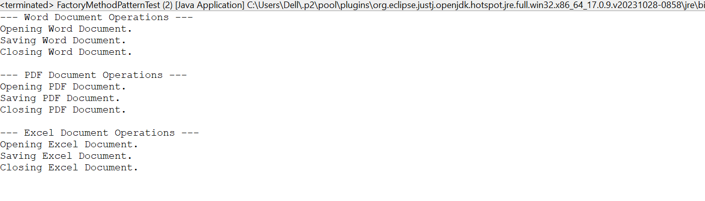

**3.ECOMMERCE SEARCH**

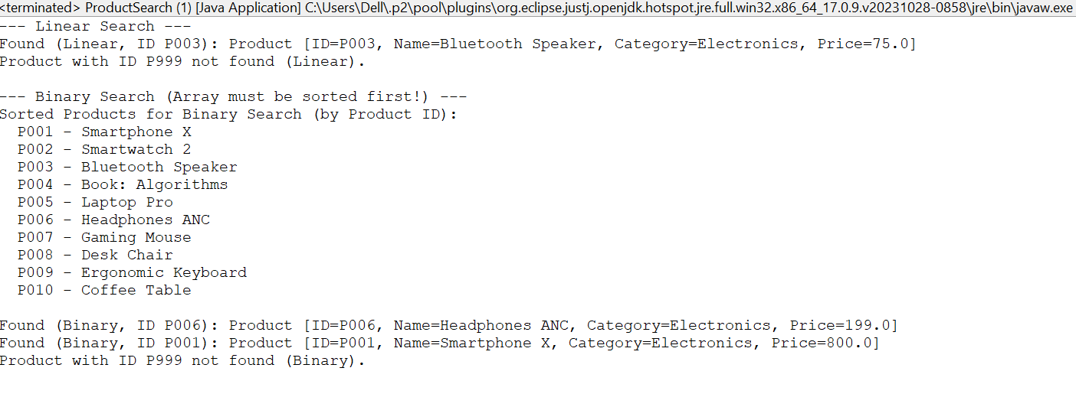

**4.FINANCIAL FORECASTING**

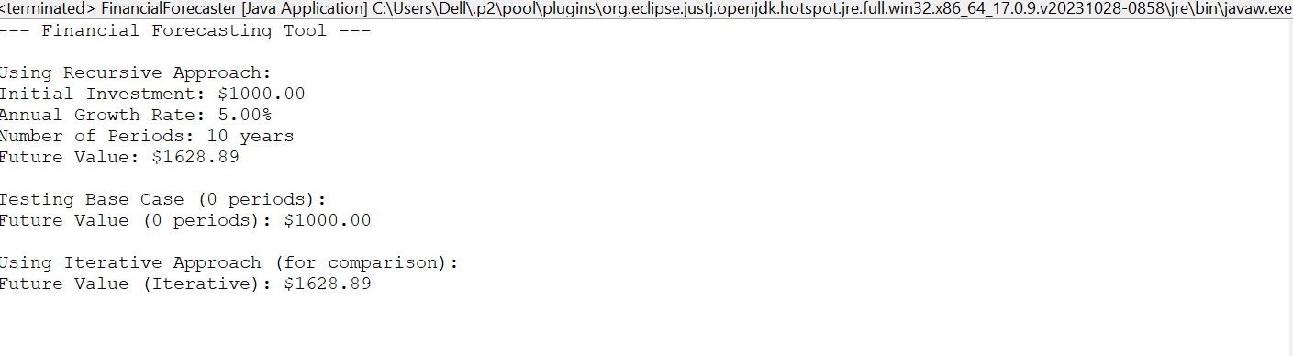

**5.ORDER SORT**

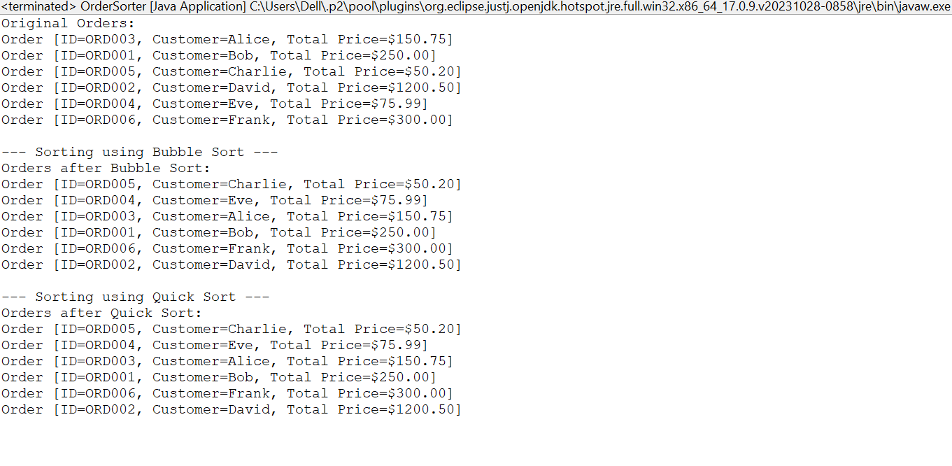

**6.STRATEGYPATTERN**

